## Инструкция по установке ЗА 5031.

Скопировать патч из директории (если ранее патч был скопирован, проверить как минимум по дате и размеру что вариант актуальный)

P:\BI_HF_

1. Установить все сценарии в ODI*.

*В отгрузке 1 сценарий необходимо заменить. Имя сценария уникально в пределах репозитория. Нужно заменить существующие с тем же именем. Может быть удобно представление ODI Designer/Load plan and scenarios. Найти нужный сценарий в представление используя на нем контекстное меню import replace заменить соответствующий сценарий новым. Подробная инструкция от вендора в приложении.

1. Новые сценарии необходимо импортировать в режиме Duplication
2. Установить Load Plan LP_LOAD_MCRM_DWH
3. В Топологии в Разделе Logical Architecture создать новую логическую схему с именем MCRM в разделе технологии XML

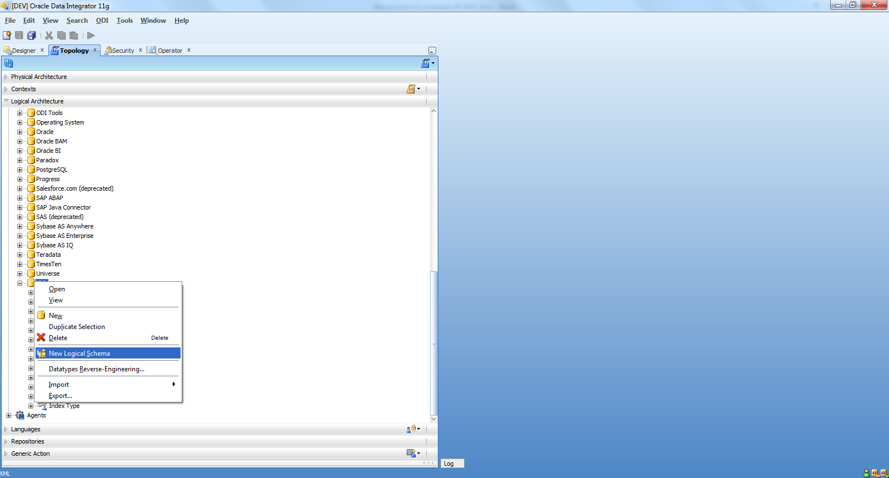

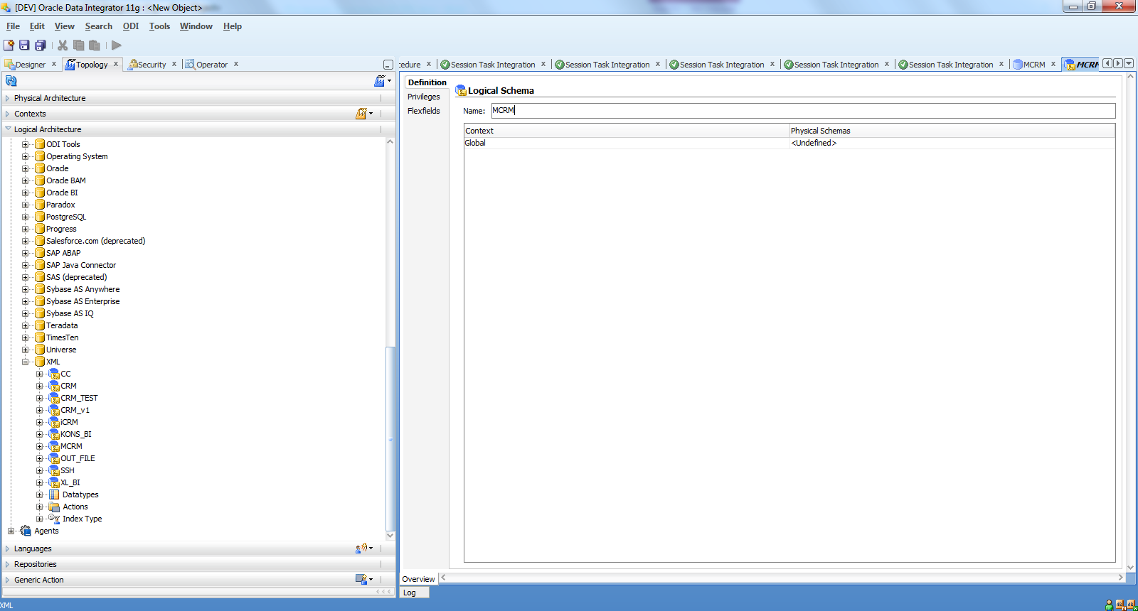

1. В закладке Physical Architecture создать новый Data Server в разделе технологии XML

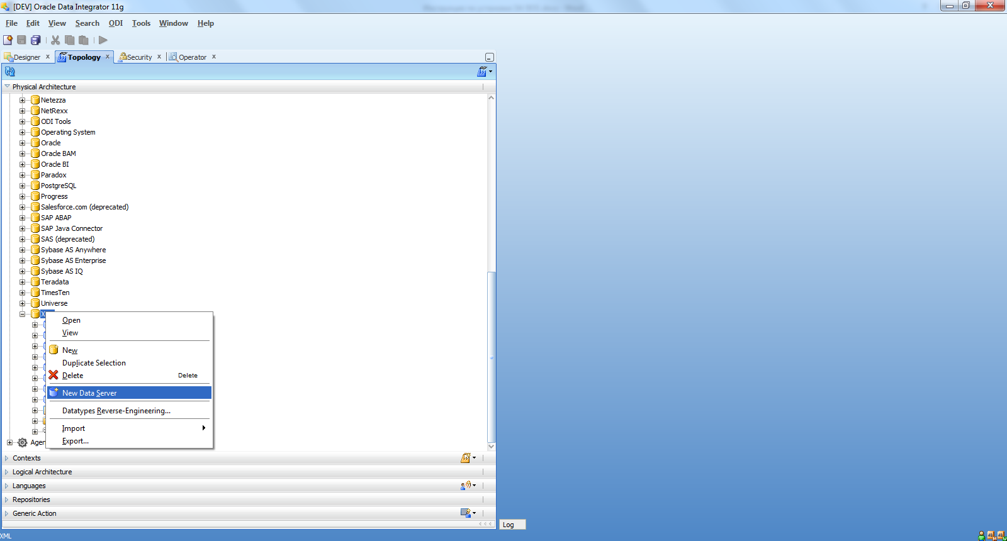

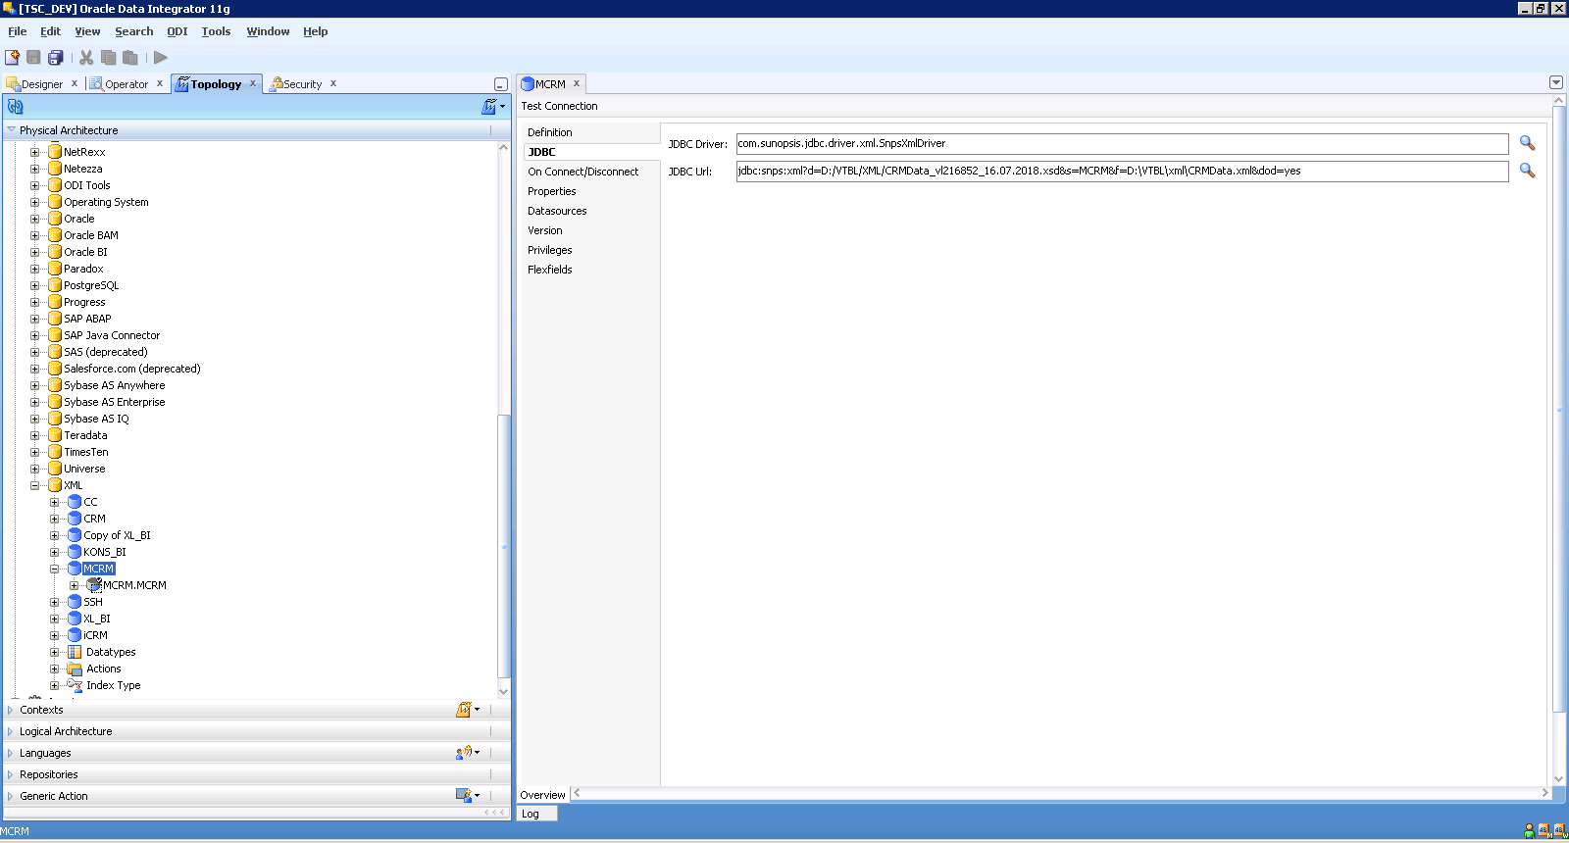

Со следующей стрококой JDBC соединения

jdbc:snps:xml?d=D:/VTBL/XML/CRMData_vl216852_16.07.2018.xsd&s=MCRM&f=D:\VTBL\xml\CRMData.xml&dod=yes

И физическую схему

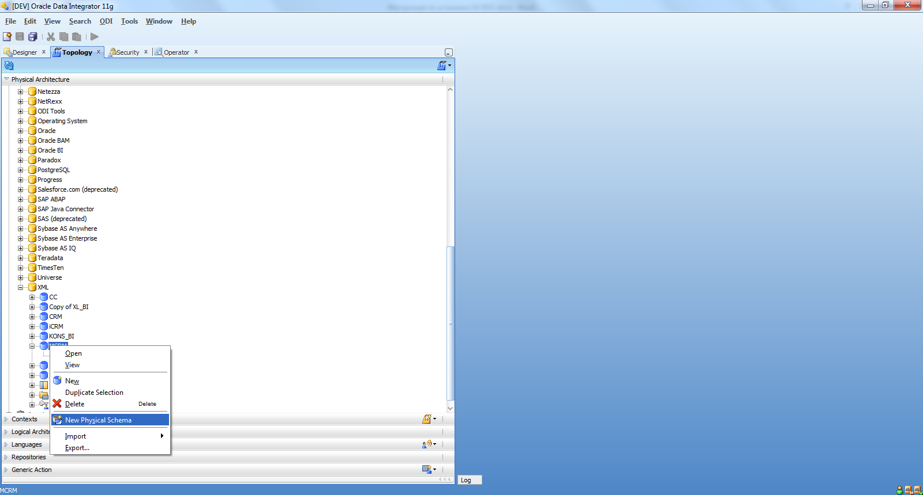

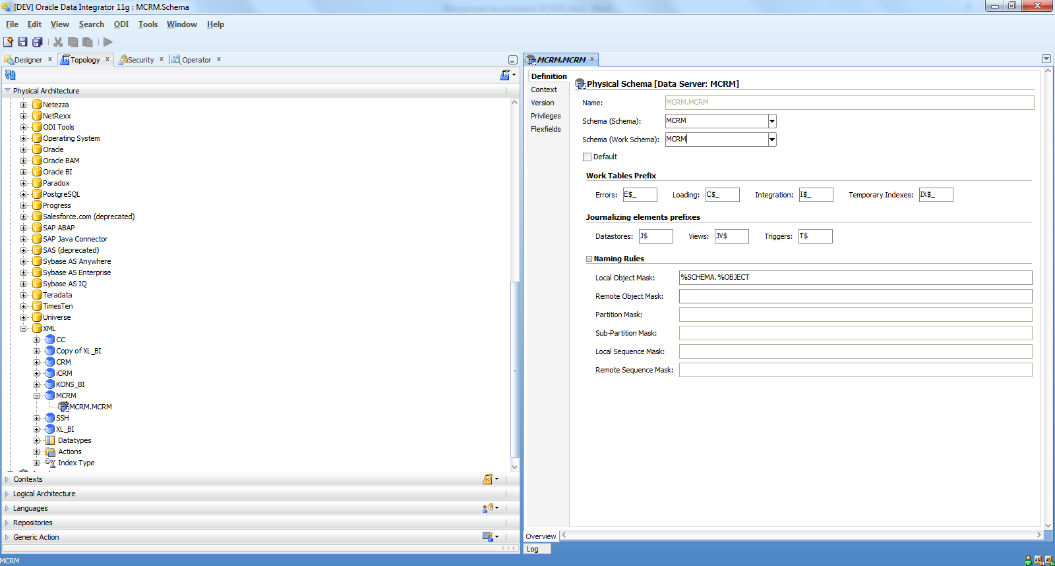

1. Установить все скрипты в базе данных, используя любое удобное приложение, например, Pl/SQL Developer.

**Приложение.**

**13.6 Importing Scenarios in Production**

A scenario generated from Designer can be exported and then imported into a development or execution repository. This operation is used to deploy scenarios in a different repository, possibly in a different environment or site.

Importing a scenario in a development repository is performed via Designer or Operator Navigator. With a execution repository, only Operator Navigator is available for this purpose.

There are two ways to import a scenario:

* Import uses the standard object import method. During this import process, it is possible to choose to import the schedules attached to the exported scenario.
* Import Replace replaces an existing scenario with the content of an export file, preserving references from other objects to this scenario. Sessions, scenario reports and schedules from the original scenario are deleted and replaced with the schedules from the export file.

Scenarios can also be deployed and promoted to production using versions and solutions. See [Chapter 19, "Working with Version Management"](https://docs.oracle.com/cd/E23943_01/integrate.1111/e12643/versioning.htm#BABCCCCB) for more information.

**13.6.1 Import Scenarios**

To import one or more scenarios into Oracle Data Integrator:

1. In Operator Navigator, select the Scenarios panel.
2. Right-click and select Import > Import Scenario.
3. Select the Import Type. Refer to [Chapter 20, "Exporting/Importing"](https://docs.oracle.com/cd/E23943_01/integrate.1111/e12643/export_import.htm#BABFIAAB) for more information on the import types.
4. Specify the File Import Directory.
5. Check the Import schedules option, if you want to import the schedules exported with the scenarios as well.
6. Select one or more scenarios to import from the Select the file(s) to import list.
7. Click OK.

The scenarios are imported into the work repository. They appear in the Scenarios tree of the Operator Navigator. If this work repository is a development repository, these scenario are also attached to their source Package, Interface, Procedure or Variable.

**13.6.2 Replace a Scenario**

Use the import replace mode if you want to replace a scenario with an exported one.

To import a scenario in replace mode:

1. In Designer or Operator Navigator, select the scenario you wish to replace.
2. Right-click the scenario, and select Import Replace...
3. In the Replace Object dialog, specify the scenario export file.
4. Click OK.

**13.6.3 Working with a Scenario from a Different Repository**

A scenario may have to be operated from a different work repository than the one where it was generated.

Examples

Here are two examples of organizations that give rise to this type of process:

* A company has a large number of agencies equipped with the same software applications. In its IT headquarters, it develops packages and scenarios to centralize data to a central data center. These scenarios are designed to be executed identically in each agency.
* A company has three distinct IT environments for developing, qualifying and operating its software applications. The company's processes demand total separation of the environments, which cannot share the Repository.

Prerequisites

The prerequisite for this organization is to have a work repository installed on each environment (site, agency or environment). The topology of the master repository attached to this work repository must be compatible in terms of its logical architecture (the same logical schema names). The connection characteristics described in the physical architecture can differ.

Note that in cases where some procedures or interfaces explicitly specify a context code, the target topology must have the same context codes. The topology, that is, the physical and logical architectures, can also be exported from a development master repository, then imported into the target repositories. Use the Topology module to carry out this operation. In this case, the physical topology (the servers' addresses) should be personalized before operating the scenarios. Note also that a topology import simply references the new data servers without modifying those already present in the target repository.

To operate a scenario from a different work repository:

1. Export the scenario from its original repository (right-click, export)
2. Forward the scenario export file to the target environment
3. Open Designer Navigator in the target environment (connection to the target repository)
4. Import the scenario from the export file